Ifremer 2026 ISMS Notes
This guide is specifically for the ISMS made for Ifremer in 2026. This model is modified slightly from prior ISMS versions and supports powering a cryotrap.
Supported firmware versions:
- Legacy-Modified: TODO add link
- Modern: TODO add link
Uploading firmware:
To upload firmware, use a USB-B cable attached to the Arduino without the rest of the instrument powered on. You must DISCONNECT the red/orange serial cable at the Arduino pins 0&1 before uploading code. Once done, reconnect the serial cable to the Arduino mega shield with the red wire in Arduino pin 0 (RX0) and the orange wire in pin 1 (TX1) /
compile and upload code:
- Legacy code use the Arduino IDE.
- Modern code, use VSCode IDE with the Platform.io extension.
Construction Differences from prior ISMS versions
- This ISMS uses newer vacuum components – the Pfeiffer MVP 010-3 DC roughing pump (model 2000020747) and Pfeiffer HiPace 80 Neo Turbomolecular pump (model 2000013626) with TC80 control unit.
- Control electronics for unused features have been removed.
- Extra 12v DC-DC converter added to provide more 12v power for the Arduino and Mini PC.
- Control of the cryotrap power is used in place of PH probe power control in prior models.
- Grounding layout is different to remove noise and serial communication errors.

Major Component schematic as shown with only ground wires visible:
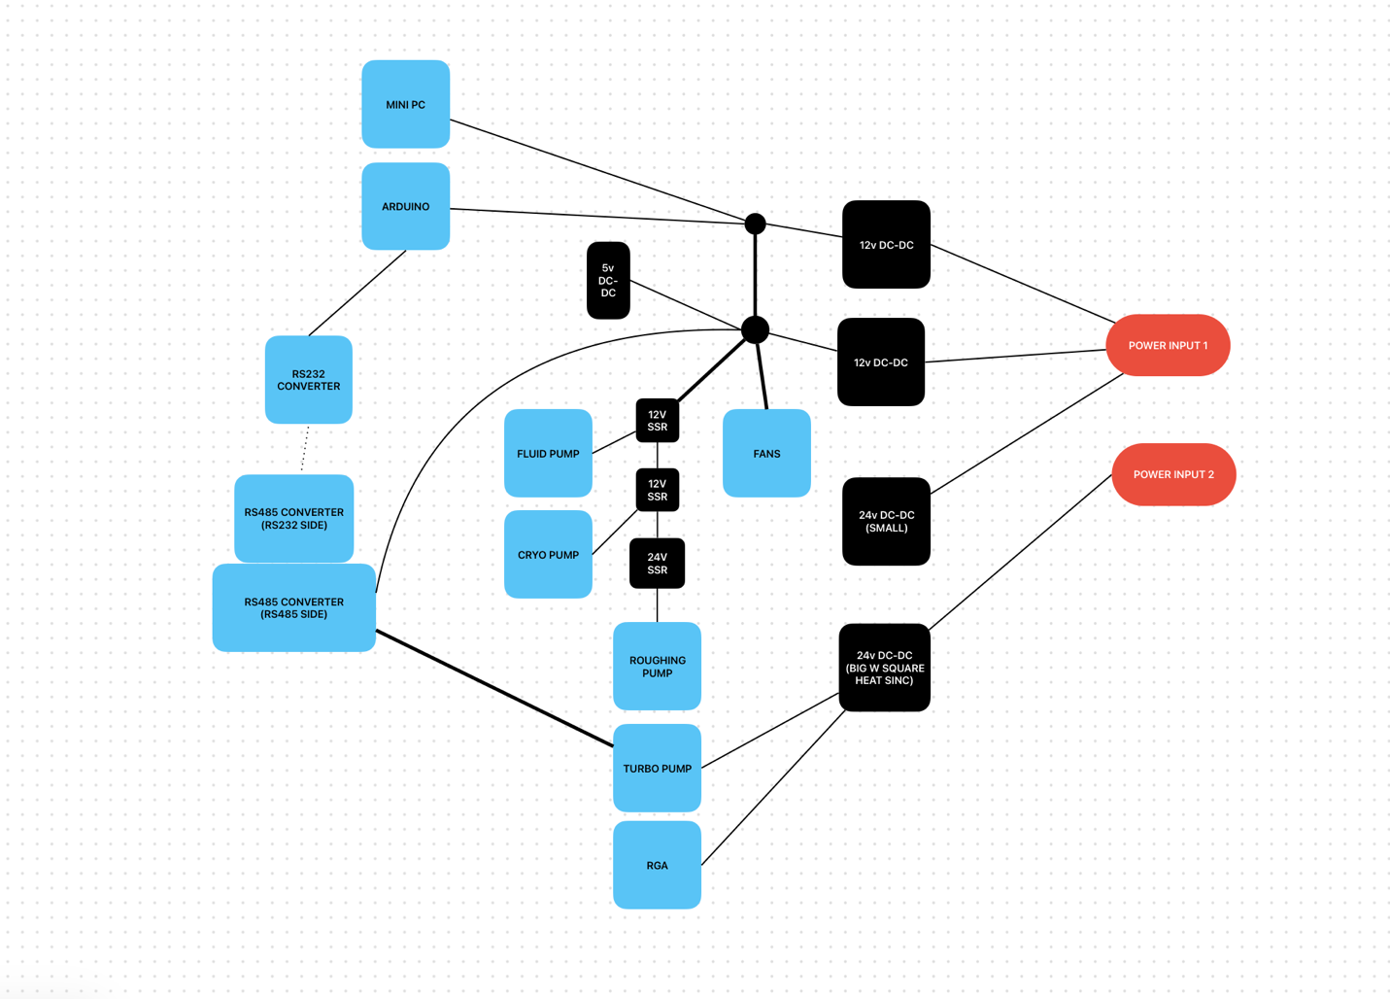
Optional Modifications
- As built the RGA rs232 cable has all 9 wires connected – many can be omitted and the instrument wil function, for example for routing the RS232 directly to the surface, only the TX, RX lines are needed (assuming the ground is already routed)
  - To make a minimal Rs232 cable work both connectors need to be made in a special way to trick the computer and RGA into thinking they are always connected when powered.
  - Follow this wiring schematic to pass the minimum required number of wires between the RS232 RGA and laptop topside RS232 Adapter:
